Tenda U3-How to install driver under Windows System
You can install the installation CD in the box.If there isn’t CD driver in your computer.You can find and download the appropriate driver for installation from http://www.tendacn.com.
Note: If you download it from the official website, the downloaded package is a zip file and you should unzip it, the result is as follows:
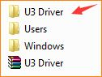
Installation steps:
1.Plug the network card into the computer's USB port, double-click the extracted folder, then double-click the Setup.exe file, as follows:
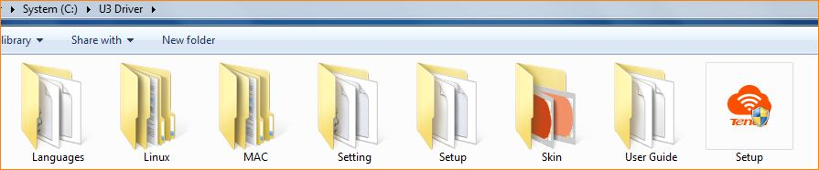
2.Then come into the Welcome page, click Install Now. If you want to change the default program installation location, click Custom in the lower left corner;

3.Wait about 1 minute in the next installation process;
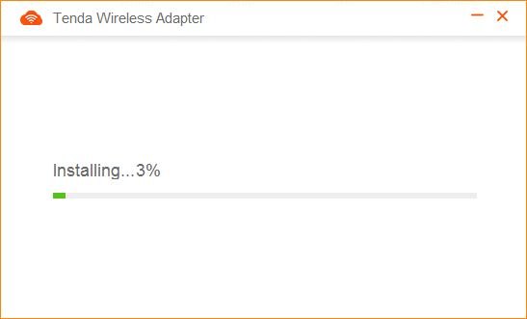
4.After the installation is completed, you can see the wifi signal list means the installation is complete.
